**Business Requirements**

**WellFit AI**

**Version 1.2**

**Date - 9th March 2025**

# **Document History**

|  |  |  |  |
| --- | --- | --- | --- |
| **Sr. No.** | **Update Description** | **Updated By** | **Version** |
| 1 | Initial Document | Shilpa Sosa George | 1.0 |
| 2 | Content Check | Akshay Kapoor & Parbon | 1.1 |
| 3 | Persona Addition | All | 1.1.1 |
| 4 | Survey Analysis Report | Musaab | 1.1.2 |
| 5 | Interview Analysis Report | Akshay | 1.1.3 |
| 6 | Format Check | Labdhi & Musaab | 1.2 |

**Table of Contents**

Document History 1

1.0 Introduction 3

1.1 Overview 4

1.2 Product Overview 4

1.3 Product Scope 4

2.0 Requirements Elicitation 4

2.1 Survey 5

2.2 Interviews or Focus Group 6

2.3 Potential Users 8

2.4 Scenarios 12

2.5 Customer Journey 15

3.0 Appendix 15

3.1Business Analysis Work Plan: 15

4.0 References 16

# **1.0** **Introduction**

## **1.1** **Overview**

The purpose of this document is to outline the business requirements for WellFit AI, which is an artificial intelligence-based fitness application providing real-time exercise tracking, calorie and water intake tracking, and personalized fitness planning. This document serves as a blueprint for the stakeholders, including developers, business analysts, and fitness professionals, ensuring alignment with business objectives and market needs.

## **1.2** **Product Overview**

WellFit AI is an AI-powered fitness application designed for athletes, trainers, and fitness enthusiasts. It offers real-time motion tracking, personalized workout routines, and AI-driven calorie and hydration tracking. The application supports wearable devices and offers multi-platform access, which makes fitness tracking more convenient and data-driven.

## **1.3** **Product Scope**

**2.0**  **Requirements Elicitation**

## **2.1** **Survey**

To assess the viability of WellFit AI, we conducted a survey targeting fitness enthusiasts, professionals, and casual users. The survey aimed to understand current habits, challenges, and expectations regarding fitness and hydration tracking. A total of 22 participants responded, providing valuable insights into user needs and preferences.  
Survey Questions and Methodology  
The survey was distributed using Microsoft Forms and included a mix of open-ended and closed-ended questions. The questionnaire covered:

* Current fitness and hydration tracking habits
* Pain points and challenges in maintaining a fitness routine
* Interest in AI-powered tracking solutions
* Desired features in a fitness and hydration app

**Key Findings and Insights:**

***1. Fitness and Hydration Tracking Habits***

* **77%** of respondents do not currently use any fitness apps.
* **45%** of respondents exercise 2-3 times per week, while **32%** exercise 0-1 times per week.
* The most common exercise types were **Cardio (36%)**, **Strength Training (27%)**, and **Yoga (18%)**.
* **59%** of respondents expressed interest in using an AI-powered fitness app, while **23%** were unsure.

#### ***2. Challenges in Maintaining a Routine***

* The biggest fitness goals reported were **weight loss, muscle gain, and overall health improvement**.
* **Lack of motivation** and **time constraints** were the most commonly cited challenges.
* Some respondents reported **difficulty in finding an effective tracking tool** that integrates hydration and fitness data.

#### ***3. Interest in AI-Powered Solutions***

* The most desired features included:
  + **AI-powered movement tracking**
  + **Personalized fitness plans**
  + **Progress insights and analytics**
  + **Goal setting and reminders**
  + **Sleep tracking**
  + **Short instructional videos**
* **32%** of respondents were highly likely to recommend WellFit AI, while another **32%** were neutral.

#### ***4. User Expectations and Feature Preferences***

* **50%** of respondents were unsure about paying for a premium version, while **41%** were unwilling to pay.
* Users suggested additional features such as **calorie and macronutrient tracking, diet plans, and form correction**.
* Concerns about **accuracy of AI recommendations and data privacy** were raised by multiple participants.
* Many respondents requested **integration with existing health and fitness apps** to streamline tracking.

**Conclusion**

The survey results validate the need for an AI-powered fitness and hydration tracking solution. The findings highlight that users seek **automated tracking, personalized recommendations, and real-time feedback** to enhance their fitness experience. WellFit AI aligns with these needs, positioning itself as a valuable solution for fitness enthusiasts of all levels. Addressing concerns about **data privacy and AI accuracy** will be critical to user adoption.

## **2.2** **Interviews or Focus Group**

As part of our requirement elicitation process, we conducted **seven** interviews with potential users to gather feedback on WellFit AI. The objective was to validate the product idea, understand user needs, and refine the customer journey based on real-world input. Each team member interviewed one person, covering fitness habits, challenges, and expectations from an AI-powered fitness and hydration tracking app.

**Key Themes from Interviews:**

1. ***Interest in AI-Powered Fitness Tracking***
   1. Most participants found the idea of **AI-powered movement tracking** appealing, particularly for improving exercise form and ensuring accurate rep counts.
   2. Users liked the idea of **hydration tracking integrated with fitness** rather than having separate apps.
2. ***Challenges in Fitness and Hydration***
   1. **Time management**: Many users struggle to maintain consistency in their fitness routines.
   2. **Tracking issues**: Some participants mentioned forgetting to log water intake and workouts.
   3. **Motivation**: A common issue was **lack of motivation**, where users wanted reminders and goal-tracking features.
3. ***Desired Features & Functionality***
   1. **Personalized workout plans**: Users want AI to suggest workouts based on their fitness levels and goals.
   2. **Automated hydration tracking**: Many respondents requested **automatic water intake tracking** instead of manual logging.
   3. **Integration with wearables**: Users prefer **syncing with smartwatches and fitness bands** for seamless tracking.
   4. **AI-driven insights**: Participants suggested having a **progress analysis feature** to show trends and improvements.
4. ***Concerns & Potential Improvements***
   1. **AI Accuracy**: Some participants questioned how accurately AI could track movement and hydration.
   2. **Data Privacy**: Users were concerned about how their fitness and health data would be stored and used.
   3. **User Interface**: Several respondents emphasized the need for a **simple, easy-to-use interface** with minimal manual input.

#### **Elicited Requirements**

Based on the interviews, the following user requirements were identified:

* **AI-powered movement tracking** should provide **real-time feedback** on exercise form and repetitions.
* The app must offer **automated hydration tracking**, preferably integrated with wearables.
* Users need **customized fitness plans** based on their activity levels and personal goals.
* A **goal-setting and motivation system** (e.g., reminders, progress tracking, and achievements) should be included.
* The app should ensure **strong data privacy policies** to protect user health information.
* **Integration with third-party fitness apps and smartwatches** is necessary for a seamless experience.
* The interface should be **user-friendly and require minimal manual entry** for tracking.

#### **Conclusion**

The interviews validated the need for WellFit AI, with strong interest in **automated tracking, AI-powered insights, and fitness personalization**. However, concerns regarding **AI accuracy, data privacy, and user experience** must be addressed to improve adoption. These insights will help refine product development and ensure that WellFit AI effectively meets user needs.

## **2.3** **Potential Users**

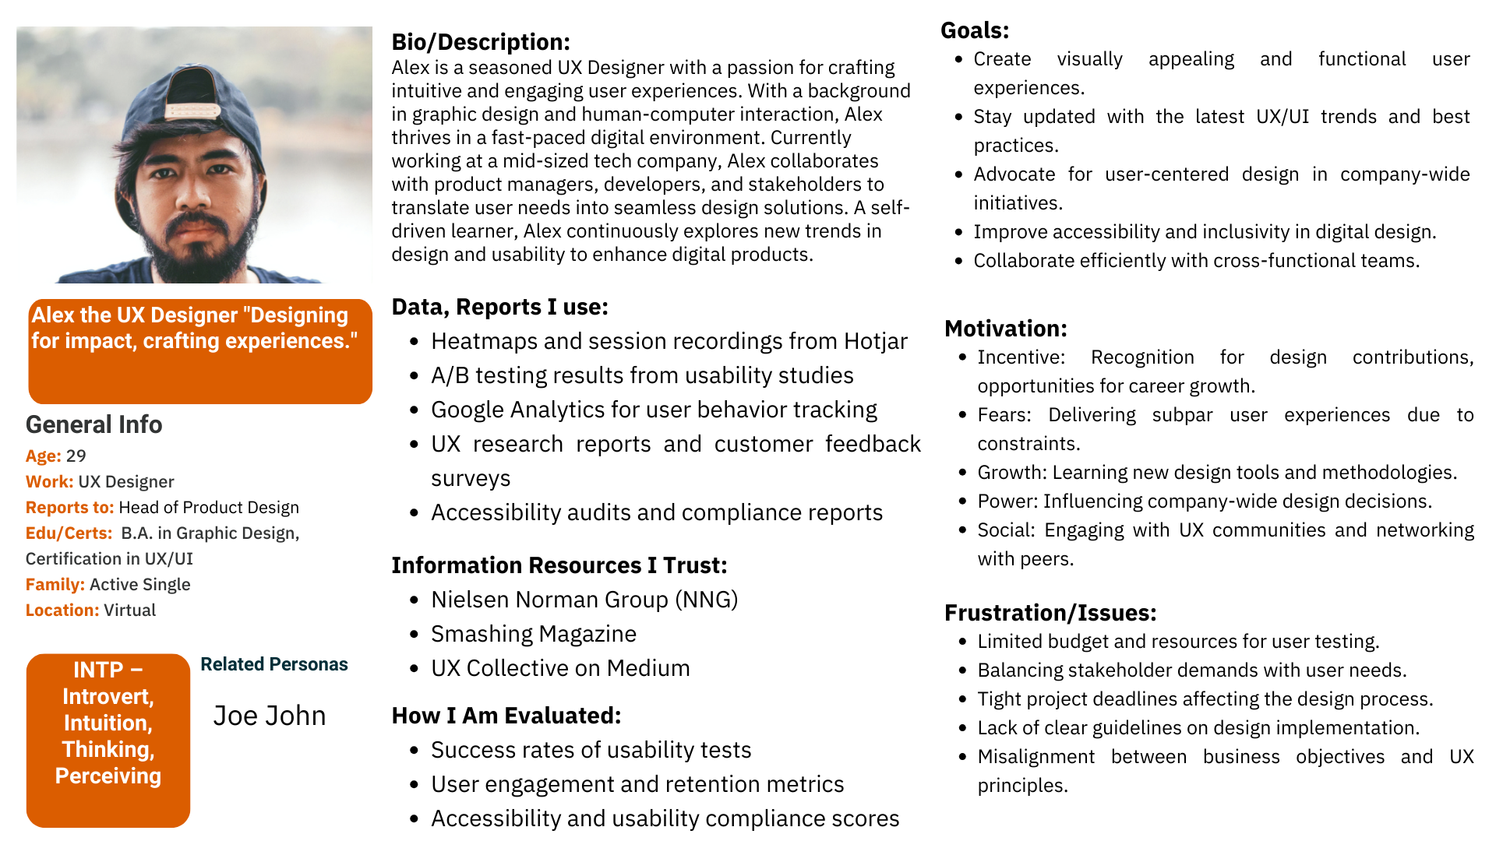

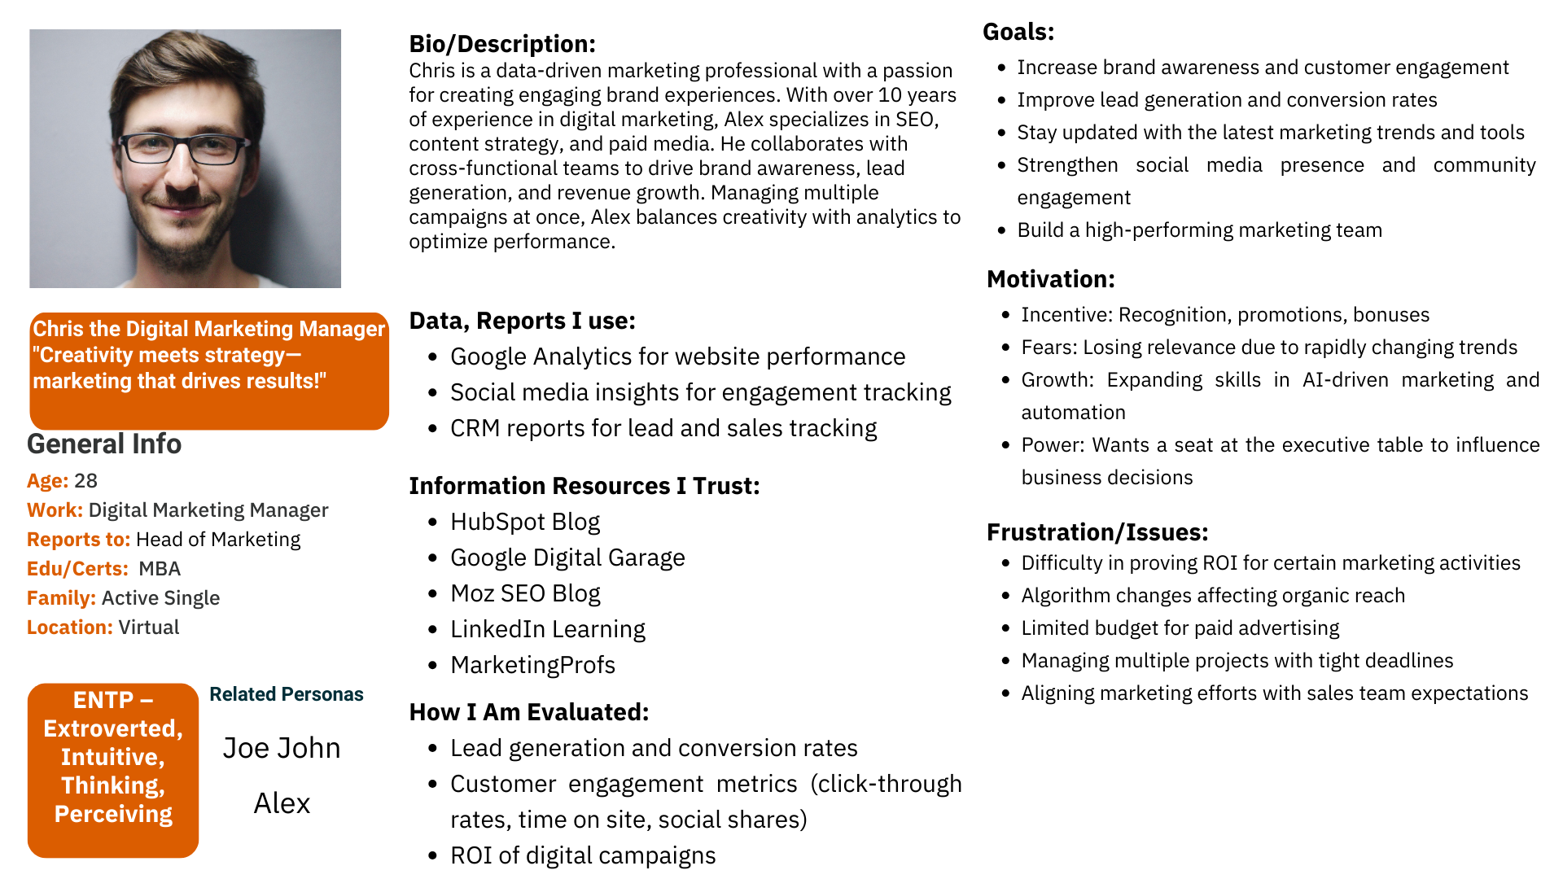

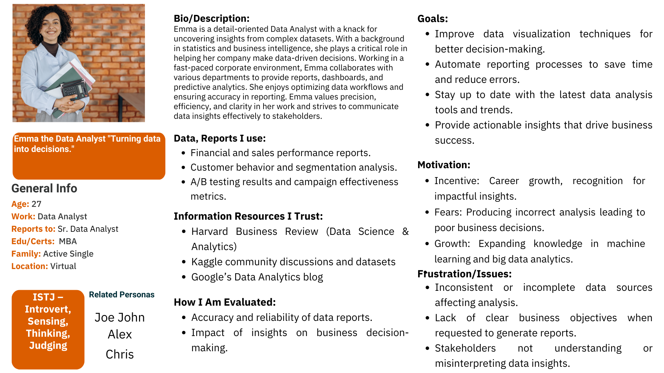

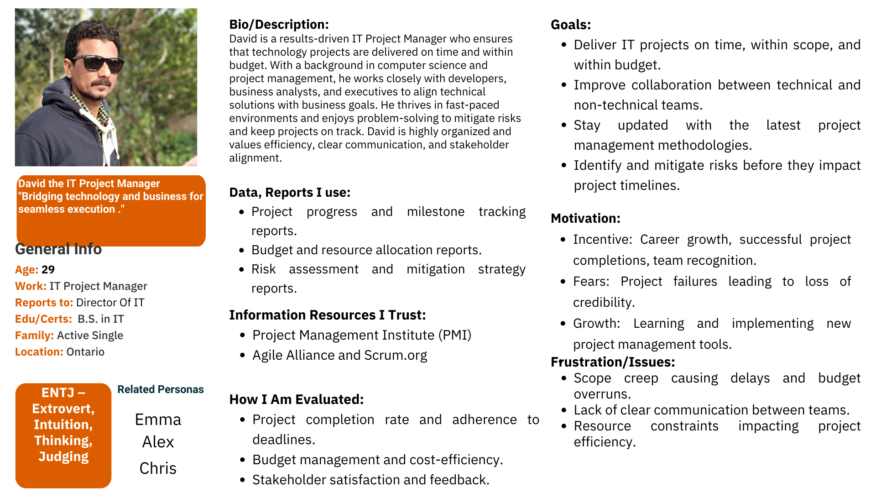  
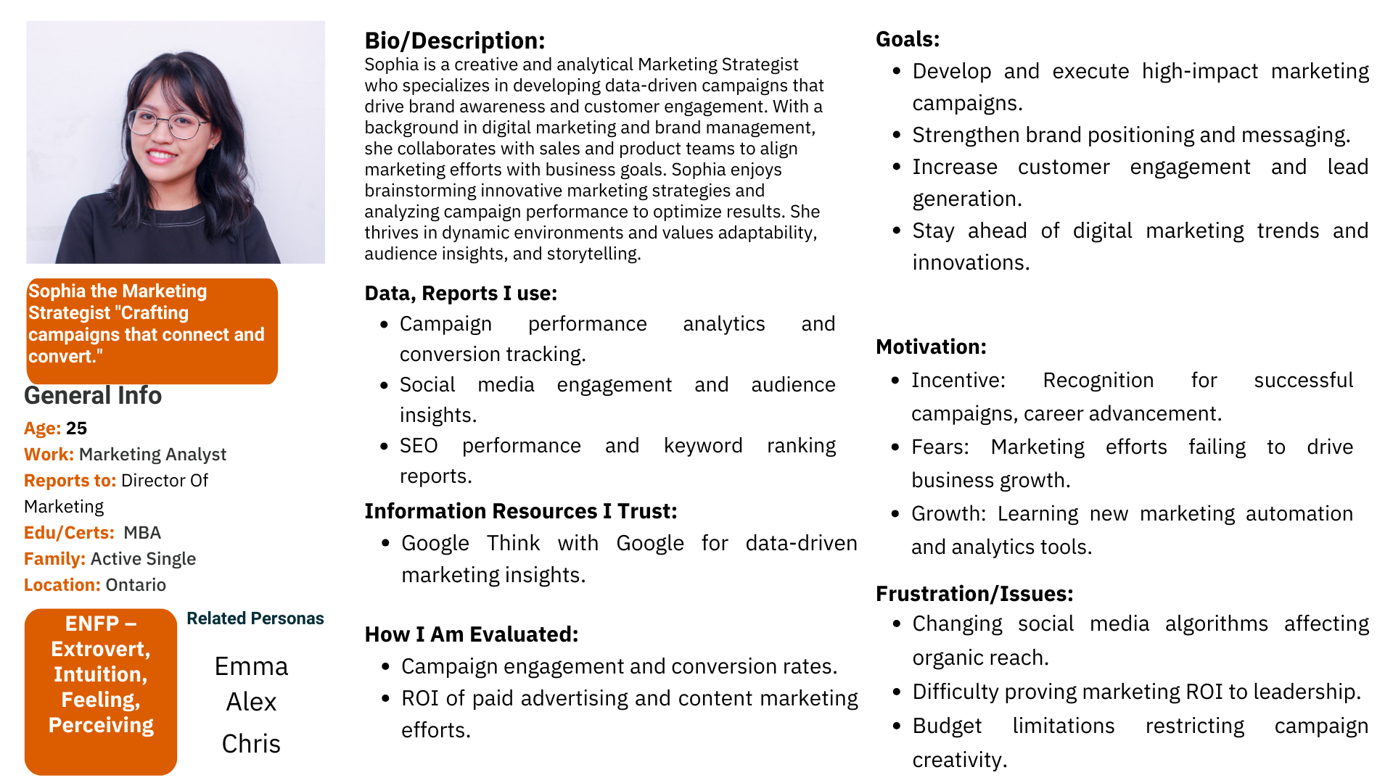

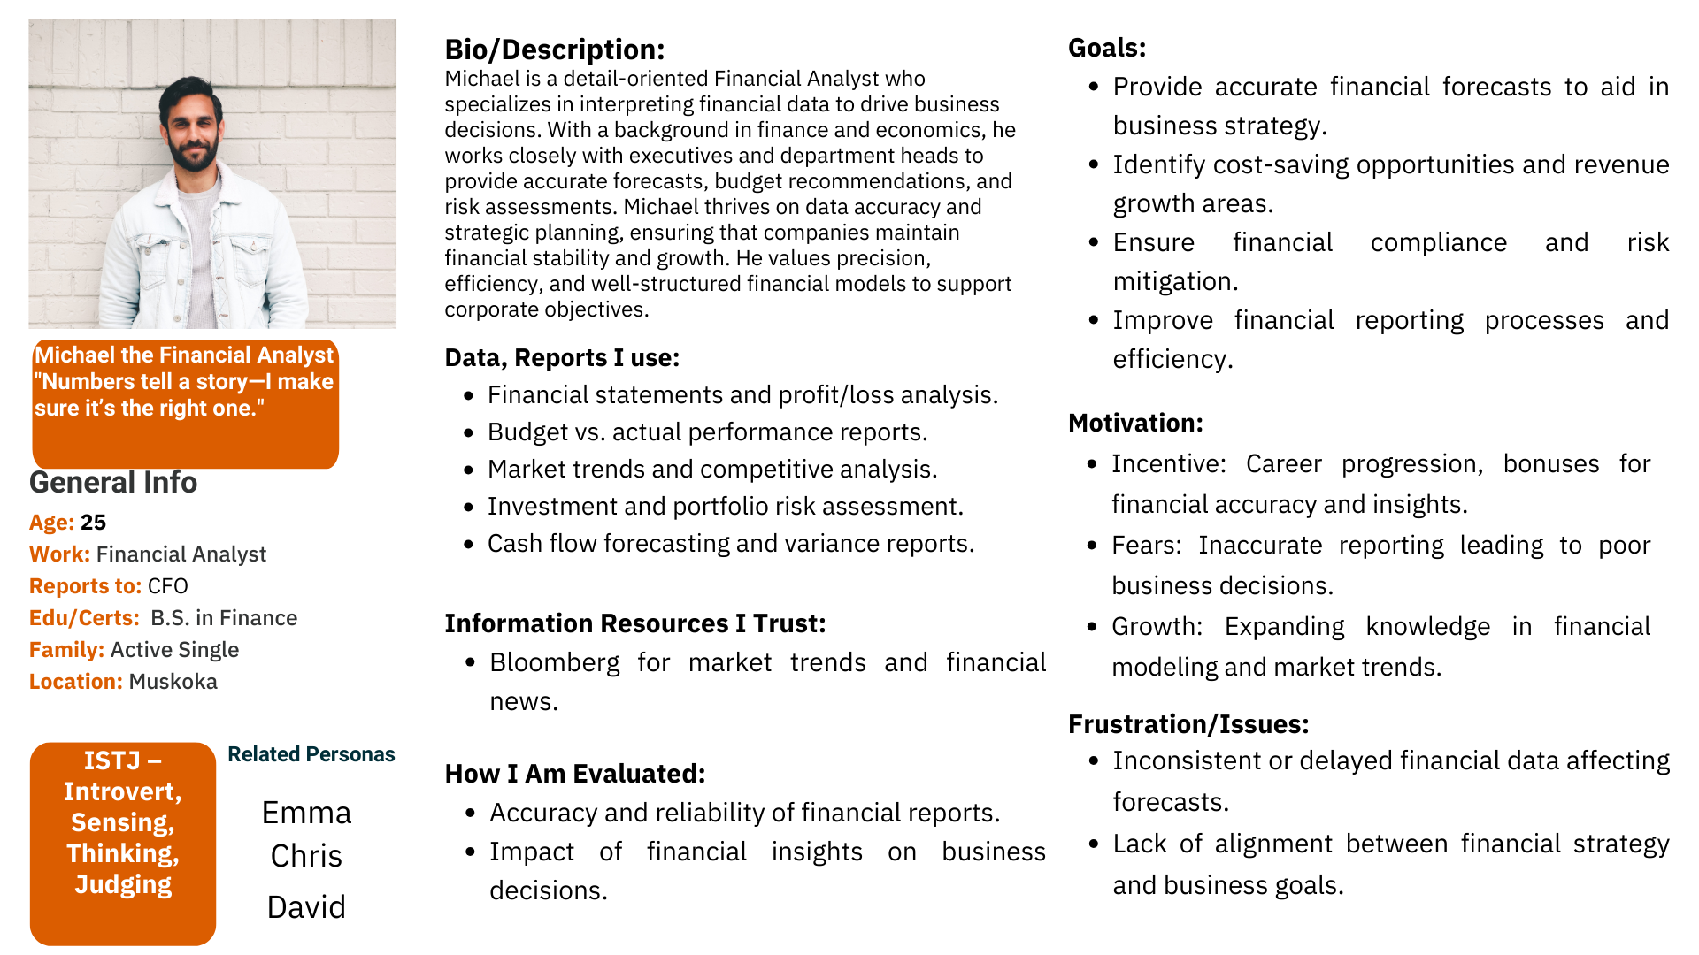

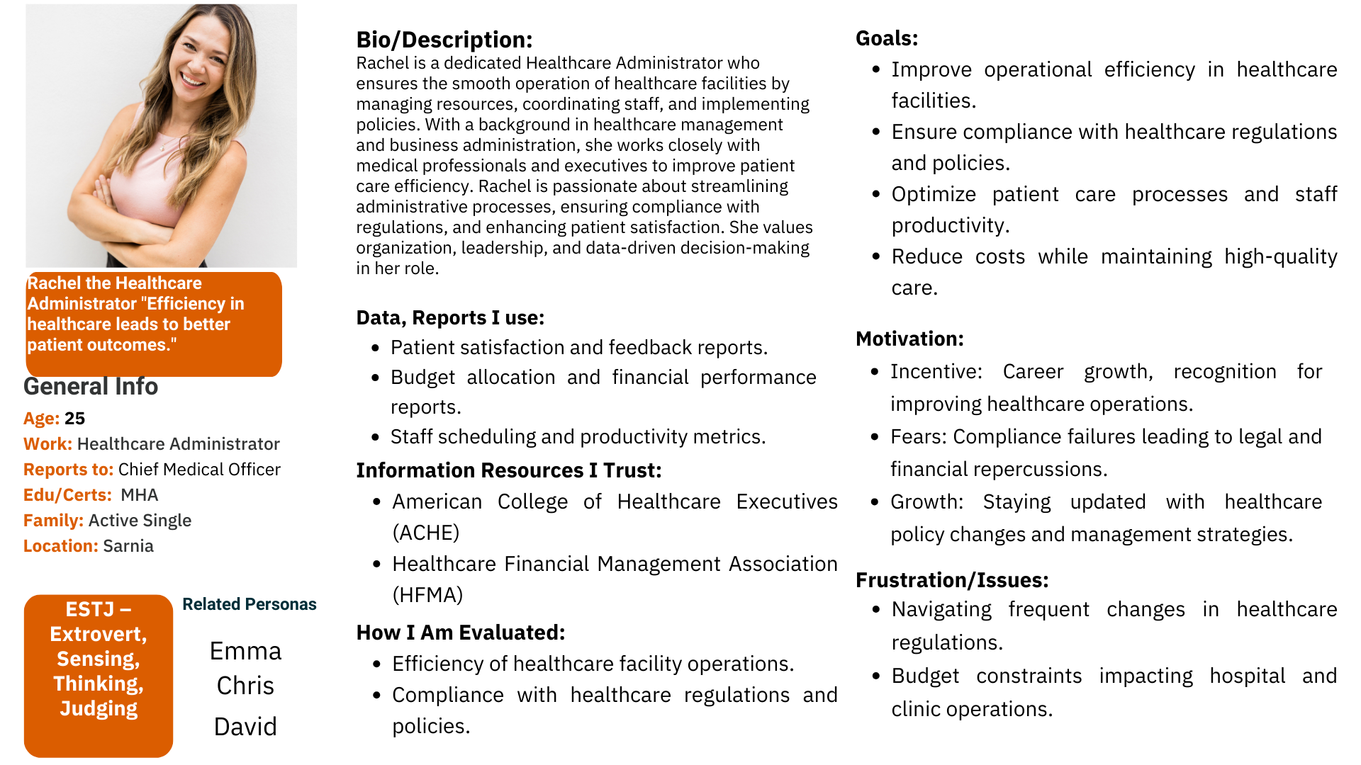

## **2.4** **Scenarios**

Write a persona scenario for one of your main product workflows. If you are working in a team, **each person on the team must write a scenario**. Your scenarios must align to your product decomposition. Your scenario must be written from the perspective of your main persona outlined in section 2.2. A scenario is a narrative of a persona completing a task in your application, it should be in business language and describe the persona’s goals and interaction with the solution. **Scenarios should not speak to the design of the system.**   
  
**Persona Scenario: Emma the Data Analyst Using WellFit AI**

Emma, a data analyst with a demanding job, often finds herself sitting at her desk for extended hours, losing track of her hydration and fitness goals. Determined to improve her overall well-being, she turns to WellFit AI, an AI-powered fitness and hydration tracking application, to help her maintain a balanced lifestyle. One morning, Emma starts her day by opening the WellFit AI app on her phone. The AI-powered dashboard greets her with a summary of her progress from the previous day, highlighting her hydration levels, exercise routine, and calorie intake. She notices a hydration alert suggesting that she has been consistently under her recommended water intake.

After reviewing her morning routine, Emma decides to follow her AI-recommended personalized fitness plan. She selects a short, guided stretching session that the app suggests, based on her sedentary work habits. As she follows along with the workout, the AI-powered motion tracking analyzes her movements, providing real-time feedback on her form and ensuring she performs each stretch correctly.

Midway through her workday, WellFit AI sends her a hydration reminder based on her activity level and environmental factors, such as the temperature and humidity in her location. Emma takes a break, drinks a glass of water, and logs her intake using the app’s one-tap tracking feature.

Later in the evening, after finishing work, Emma checks the WellFit AI progress analytics to review her hydration and fitness trends for the week. She notices that her hydration levels have improved over the past few days due to the AI reminders, and her movement data suggests that she has been more active compared to the previous week. Motivated by this progress, she sets a new goal to increase her daily water intake and extend her evening workout sessions.

By integrating seamlessly into her daily routine, WellFit AI helps Emma stay accountable for her hydration and fitness goals, making it easier for her to maintain a healthy work-life balance.

**Persona Scenario: Joe - Track Water Intake**

Joe is a tech-savvy software engineer who prioritizes his fitness but often struggles to maintain adequate hydration throughout his busy workday. He realizes that his energy levels drop, impacting both his work outputs and his gym performance. Although he is careful about other parts of his fitness routine, he often forgets to drink water, and manually tracking it appears to be a task. Joe sets his own personalized hydration goals in WellFit AI. The app sends timely reminders to his phone throughout the day, adapting to his schedule and workout intensity. He records his water intake with a quick tap, receiving immediate feedback about his hydration levels and how it impacts his fitness. Joe views the hydration report at the close of the day, appreciating the recommendations. With WellFit AI, he keeps himself well-hydrated safely, increasing his energy and performance.

**Persona Scenario: Alex – Consistency in fitness Journey**

Alex often gets immersed in work, making it difficult to track fitness and hydration consistently. He appreciates AI-powered tracking, especially if the UI is intuitive and easy to use. When using WellFit AI, Alex starts his day by checking his personalized fitness recommendations and hydration goals. During workouts, the AI-powered motion tracking ensures proper form, which he finds useful. The hydration reminders help him stay on track, as he often forgets to drink water. At the end of the day, Alex reviews his progress insights, which motivate him to maintain consistency in his fitness routine.

**Persona Scenario: Chris – Workout performance**

Chris struggles with motivation and often works long hours, making it hard to prioritize fitness. He likes the concept of AI-powered tracking but is skeptical about its accuracy without manual input. While using WellFit AI, Chris receives real-time feedback on his workout performance, which helps him stay engaged. The hydration tracker automatically adjusts his water intake reminders based on his activity level. Over time, Chris finds the AI-generated progress reports helpful in recognizing patterns and making small improvements in his fitness routine.

**Persona Scenario: David – Hydration**

David has a hectic schedule filled with meetings and project deadlines, often leaving little time for fitness. He values minimal-effort tracking and appreciates that WellFit AI automates much of the process. The app sends him quick hydration reminders and suggests short, effective workouts tailored to his available time. During breaks, David follows the app’s recommended mobility exercises, ensuring he stays active despite his sedentary job. At the end of the week, the app provides insights into his hydration and activity trends, allowing him to make adjustments to his routine.

**Persona Scenario: Sophia – Userfriendly app for fitness**

Sophia travels frequently for work, making it challenging to maintain a consistent fitness routine. She enjoys using WellFit AI because it adapts to her changing schedule. The app syncs with her smartwatch, tracking her activity and hydration automatically. On busy days, WellFit AI suggests quick, high-intensity workouts to maximize efficiency. The AI-generated progress insights and goal-setting features help her stay motivated, even when she’s on the go. Sophia appreciates the convenience and flexibility WellFit AI offers, making it easier to integrate fitness into her lifestyle.

**Persona Scenario: Michael – Structuring and improving his fitness**

Michael values efficiency and dislikes manually tracking fitness data. He uses WellFit AI because it saves time while providing accurate insights. The AI-powered motion tracking ensures he performs exercises correctly, reducing the risk of injury. The app also monitors his hydration levels and provides automated reminders based on his daily routine. Michael enjoys reviewing his weekly progress reports, which highlight trends in his fitness and hydration habits. With minimal effort, he can maintain a structured fitness routine that fits into his busy work schedule.

**Persona Scenario: Rachel – Mental and Physcial Health maintenance**

Rachel understands the importance of staying active but often prioritizes work over personal fitness. She uses WellFit AI to help her stay accountable. The app recommends stress-relieving exercises based on her activity levels and work schedule. AI-powered hydration tracking adjusts her intake goals depending on her stress levels and workload. At the end of each week, she reviews her progress and sets new fitness goals. Rachel finds that WellFit AI helps her maintain balance between work, fitness, and overall well-being.

**Conclusion**

Through these interviews, it’s clear that WellFit AI addresses common challenges such as **lack of time, motivation, and consistency in tracking fitness and hydration**. Personas appreciate features like **AI-powered tracking, automated reminders, and progress insights**. By refining **AI accuracy, data privacy, and UI simplicity**, WellFit AI can better serve its users and improve adoption rates.

## **2.5** **Customer Journey**

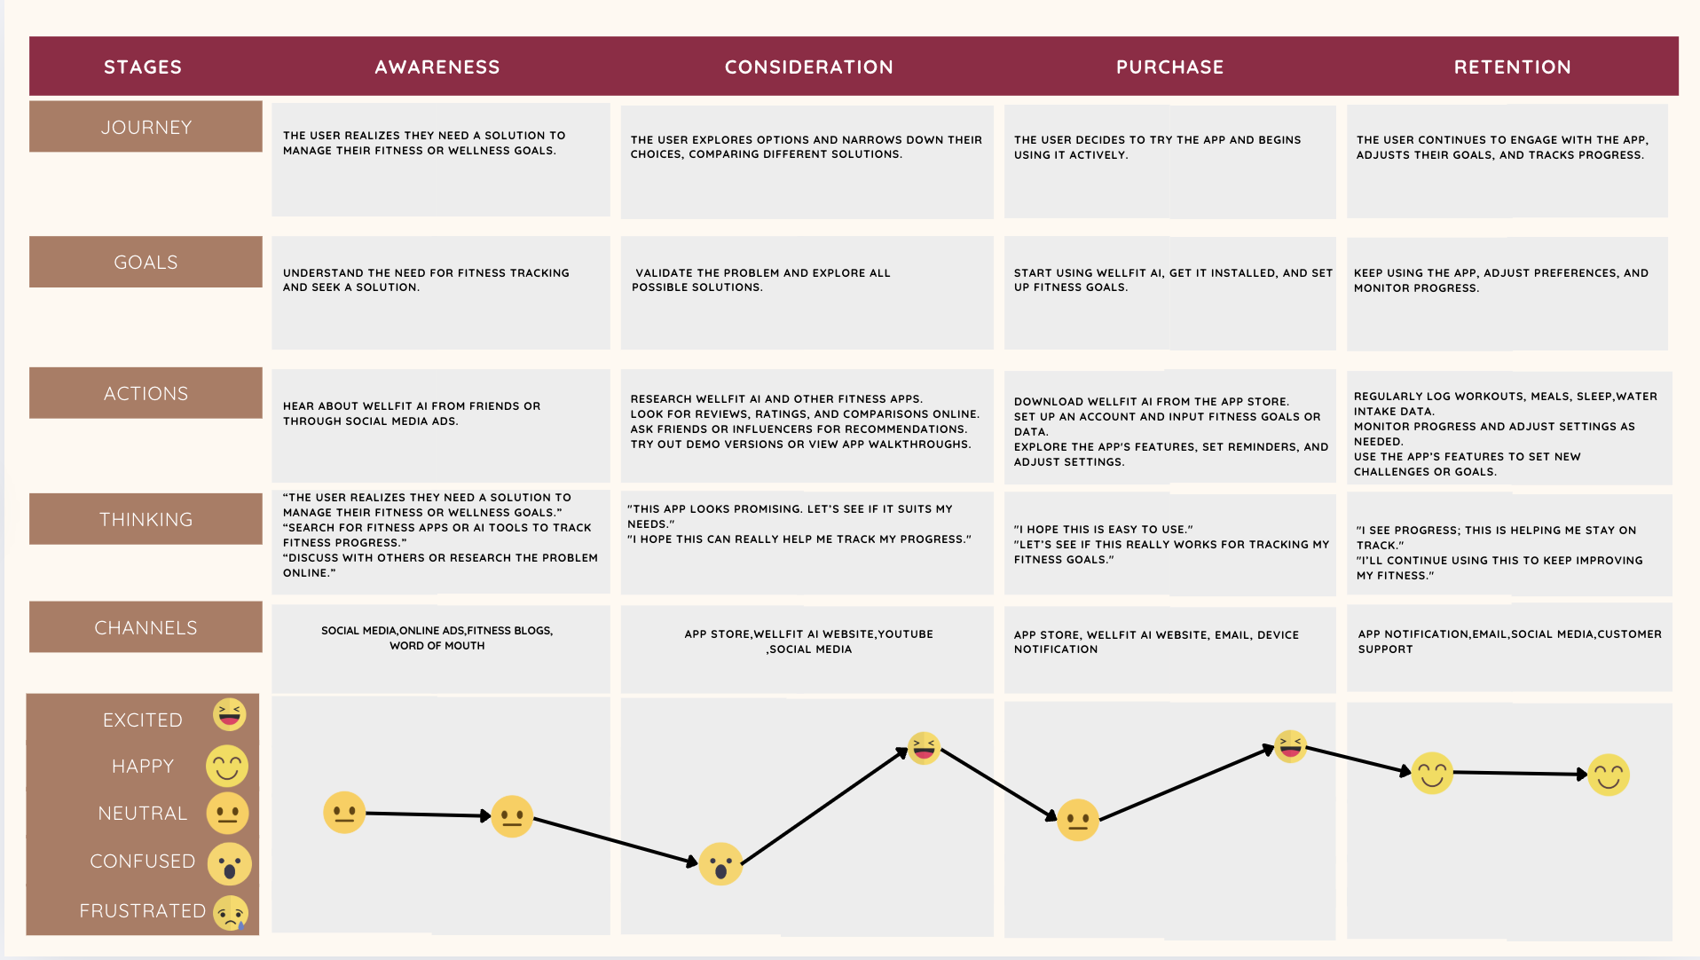

# **3.0 Appendix**

## **3.1** **Business Analysis Work Plan:**

|  |  |  |  |  |
| --- | --- | --- | --- | --- |
| **Task ID** | **Task Name** | **Assigned To** | **Status** | **Completion Date** |
| 1.3 | Product Scope | Shilpa | Completed | Feb - 01 |
| 2.0 | Requirements Elicitation | All team members | Completed | March - 01 |
| 3.0 | Document Testing | Shilpa & Akshay | Completed | March - 08 |
| 4.0 | Content Verification | Musaab & Labdhi | Completed | March - 08 |

# **4.0 References**

Angosto, S., García-Fernández, J., & Grimaldi-Puyana, M. (2023). A systematic review of intention to use fitness apps (2020–2023). *Humanities & Social Sciences Communications, 10*, 512. <https://doi.org/10.1057/s41599-023-02011-3>

Bracaglia, D. J. M. (2025, January 15). Best fitness trackers 2025: Tested and rated for every budget. *Tom’s Guide*. <https://www.tomsguide.com/us/best-fitness-trackers,review-2066.html>

Microsoft Forms. (2025). *WellFit AI User Survey Results*. Internal team data.

Project Team. (2025). *Group 8 Deliverable 1 Part 2: Project Vision*. Internal team document.